Software developers need to be able to design complex systems that are easy to understand. One way to visually organize such systems is through UML component diagrams.
A UML component diagram shows how components relate to each other within a larger system. A system component is a module that’s part of a larger hardware and software system. It has its own inputs and outputs and specific interfaces with other system components.
UML component diagrams are different from other types of UML diagrams. They are not used to design the system, but rather to show the organization of components as they will be implemented. The components are such elements as files, documents, libraries, software modules, even packages of modules.
UML component diagrams show the structure of the components of a system’s architecture and how the components are connected and interact. For example, an online shopping system has payment gateways, product catalogs, shopping carts, etc. A component is an element of a system that can be replaced without affecting the rest of the system.

What is a Component Diagram?
A component diagram, also known as a UML component diagram, describes the organization and wiring of the physical components in a system. Component diagrams are often drawn to help model implementation details and double-check that every aspect of the system's required functions is covered by planned development. In the first version of UML, components included in these diagrams were physical: documents, database table, files, and executables, all physical elements with a location. In the world of UML 2, these components are less physical and more conceptual stand-alone design elements such as a business process that provides or requires interfaces to interact with other constructs in the system. The physical elements described in UML 1, like files and documents, are now referred to as artifacts. A UML 2 component may contain multiple physical artifacts if they naturally belong together.

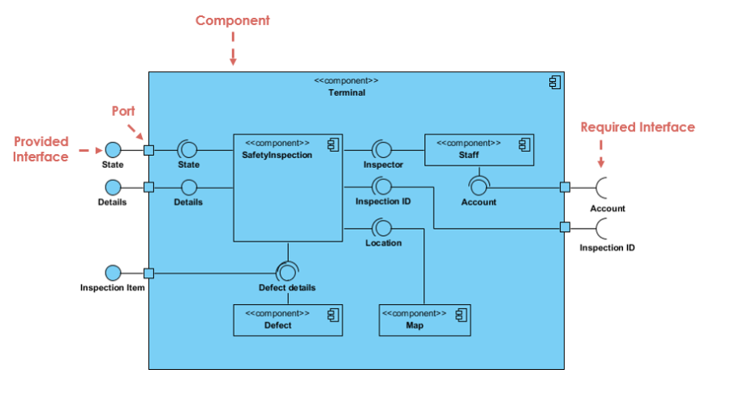

Purpose of component diagrams
Component diagrams help to identify which components are necessary for a particular product. Besides that, they show the relationships between components.
Component diagrams are a higher level view than a class diagram. While a class diagram shows classes, their attributes and methods, and the relationships between objects, component diagrams include one or more components, and each component usually contains multiple classes.
Perhaps most importantly, component diagrams make the structure of a software system clear. You can see the software components and their interfaces, as well as the dependencies with other components.
These diagrams show the implementation structure of a system so developers know how to maintain and change it. They also show dependencies among components, which can help identify issues.
Component diagrams show a system’s physical structure or physical aspects. They can be high level or detailed. Each component that is modeled provides a specific service and behaves in a certain well-defined way. The connectors between them have specific meanings, too.
System architects use UML component diagrams to check for design flaws or identify performance issues if things are too slow. They also help them to understand how different components work together.
UML component diagrams can also be used as a communication tool. Developers can quickly and easily explain the structure of a system to colleagues or clients.
Component diagrams provide a documented view of the system as implemented. This is especially useful for those joining a project in progress, or who need to make changes to a particular component.

Basic Component Diagram Symbols and Notations

1.Component
A component is a logical unit block of the system, a slightly higher abstraction than classes. It is represented as a rectangle with a smaller rectangle in the upper right corner with tabs or the word written above the name of the component to help distinguish it from a class.

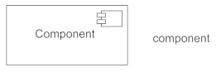
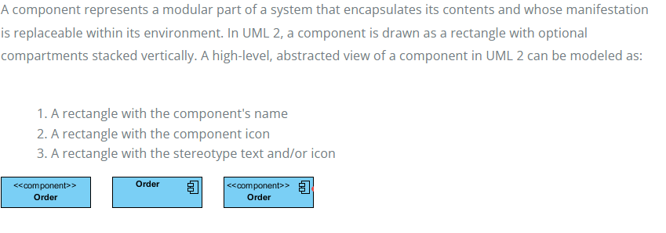

2.Interface
An interface (small circle or semi-circle on a stick) describes a group of operations used (required) or created (provided) by components. A full circle represents an interface created or provided by the component. A semi-circle represents a required interface, like a person's input.

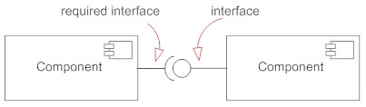
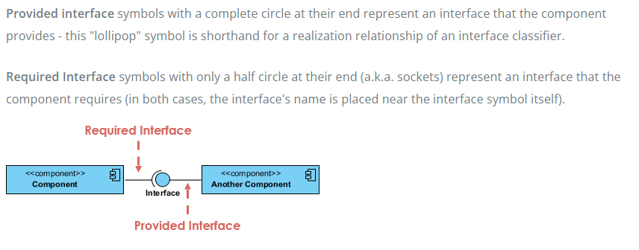
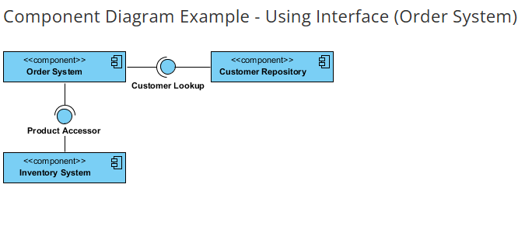

Dependencies
Draw dependencies among components using dashed arrows.

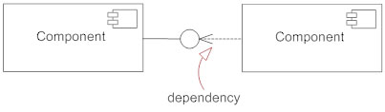

Port
Ports are represented using a square along the edge of the system or a component. A port is often used to help expose required and provided interfaces of a component.

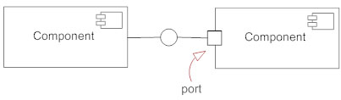
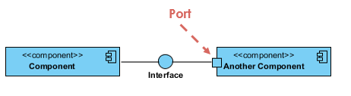

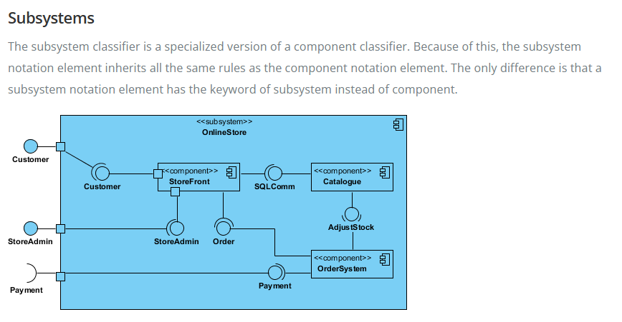

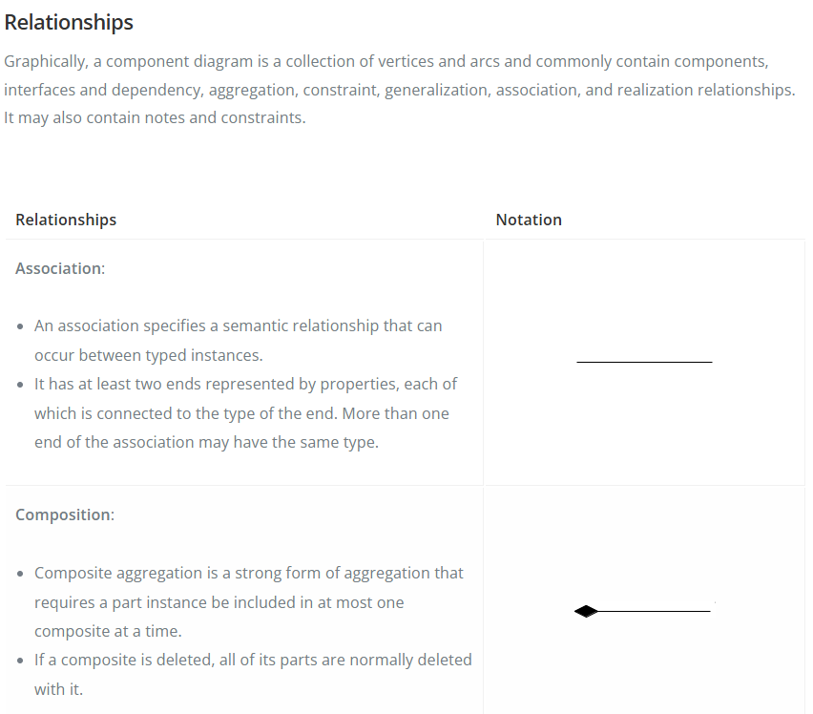

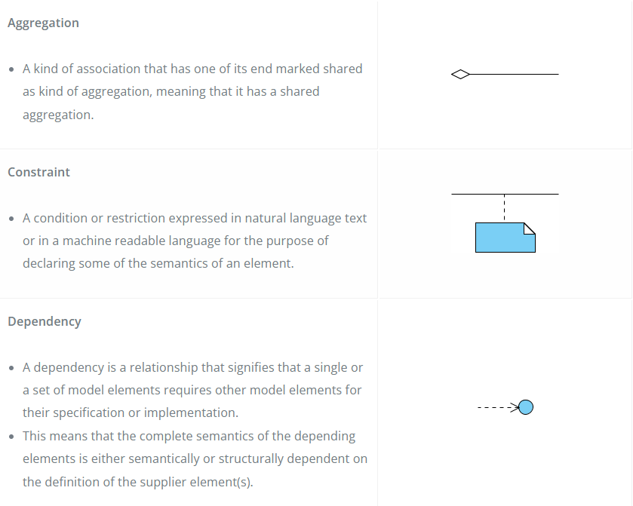

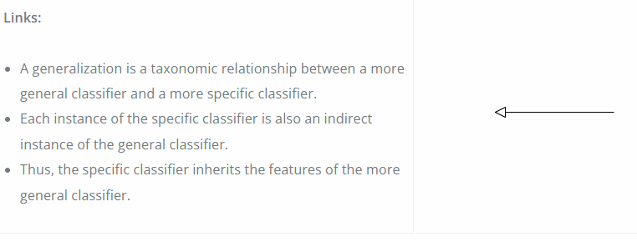

When to use a component diagram
For example, let's look at an online shopping system. The main components include:
- Payment gateways such as PayPal, Strip, or Adyen (for the actual customer checkout).
- Product catalogs (where customers can browse products).
- Order processing systems (which handle orders from customers).
- Customer service systems (to provide support for customers).
Each component has its own set of subcomponents. These further define their functionality within the system architecture.
When creating a UML component diagram, developers need to understand several key elements:
Component: A part of a system that has its own functionality and behavior.
Interface: An interface is a method or set of methods used by another component. A given component can provide interfaces to other components, and/or it can require interfaces from other components.
Port: A place where a component interacts with its environment and sends messages.
Connector: A way two components can communicate.
Dependency: A dependency where one component depends on another.

How to Draw a Component Diagram

Identifying components and interfaces
The first step in creating a UML component diagram is to identify the components and interfaces that'll make up the diagram. A component represents a specific part of the system. And an interface represents the way two components interact. (There are other ways two components interact, but this is the most common). This step is crucial as it lays the foundation for the rest of the diagram.
When identifying components and interfaces, it's important to consider the system and its parts. Each component has a clear and defined purpose. And each interface should be well-defined and easy to understand. This will ensure that the diagram accurately represents the system and is easy to read and interpret. It also ensures that components can be replaced cleanly without impacting other components.

Defining ports and connectors
Defining components, interfaces, and ports is crucial. Ports allow components to send and receive signals, while connectors define how data and signals flow between the ports. This step determines how the various components will interact with each other.
Be sure to think about what each component needs when defining ports and connectors. Each port should meet the needs of the component it belongs to, and each connector should help the flow of data and signals between the ports it connects to. This will ensure the system is implemented well.

Establishing dependencies
You need to know what's needed to make something work. This is called dependency. If a component needs another one, then the first one is dependent on the second one. This step is important because it makes sure that all components are needed and that the system works as expected.
Think about how the parts are connected when you're setting dependencies. Each one should be clear and easy to understand, and each should minimize how much it depends on others. This makes it easier to maintain and change the system.

- Take stock of everything needed to implement the planned system. For example, for a simple e-commerce system, you'll need components that describe products, orders, and customer accounts.
- Create a visual for each of the components.
- Describe the organization and relationships between components using interfaces, ports, and dependencies.

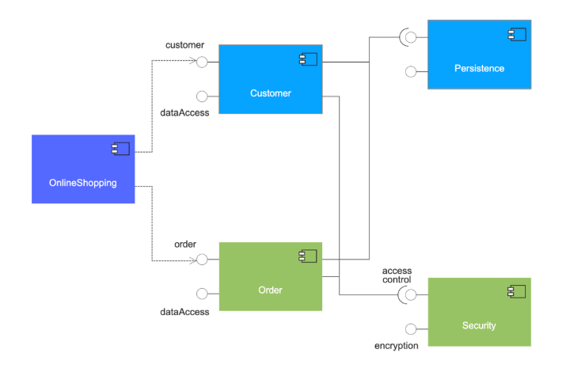

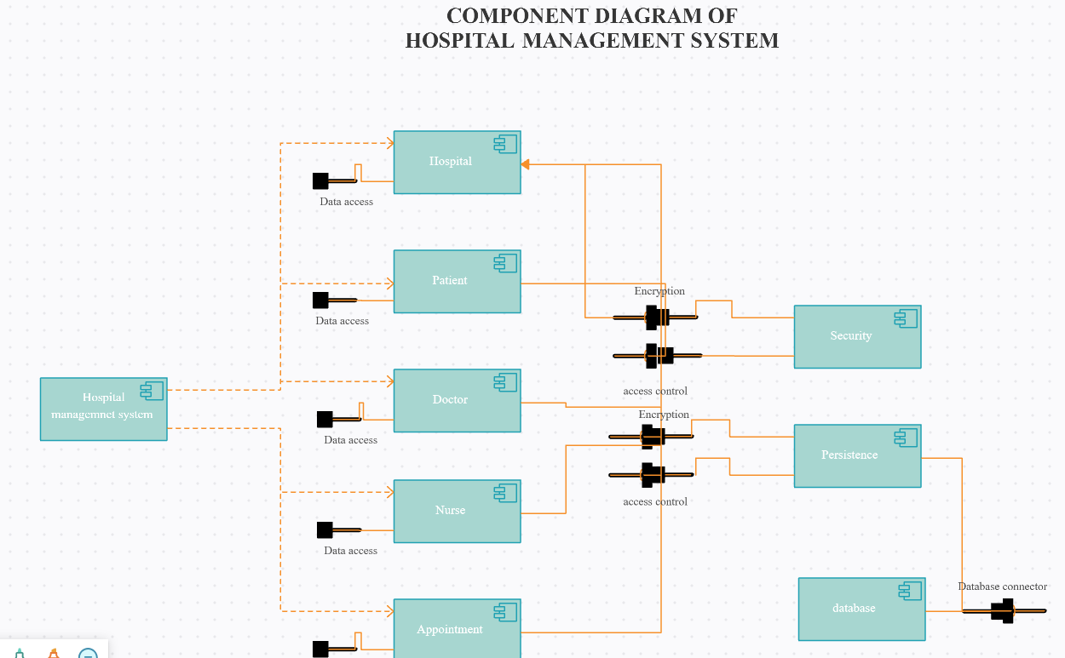

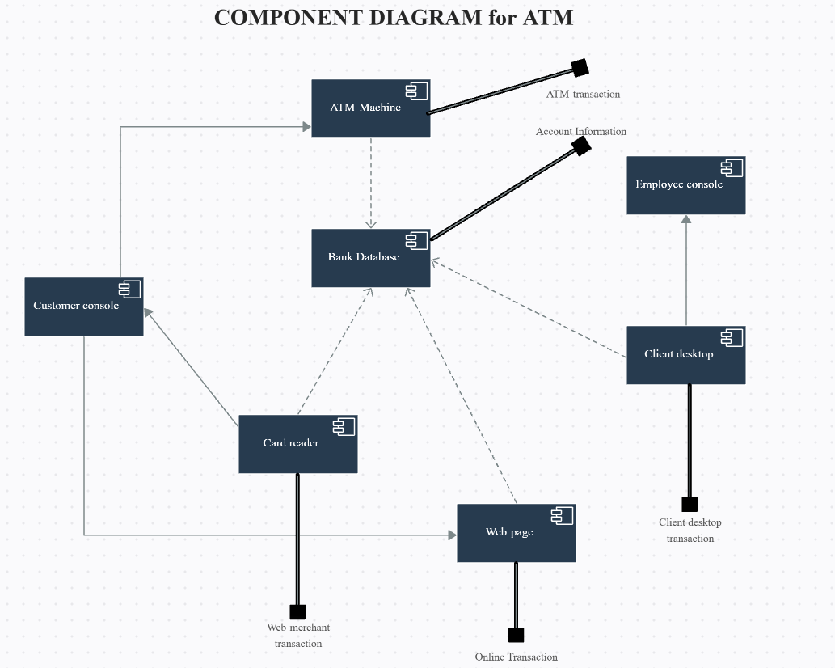

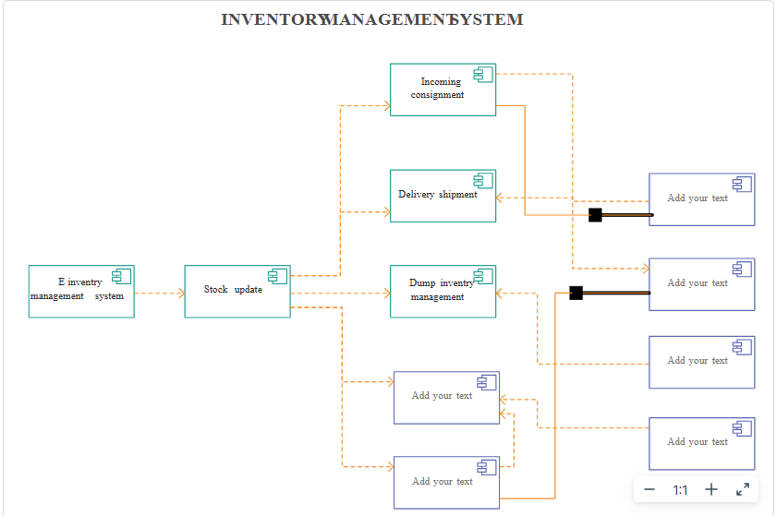

Modeling a Physical Database
- Identify the classes in your model that represent your logical database schema.
- Select a strategy for mapping these classes to tables. You will also want to consider the physical distribution of your databases. Your mapping strategy will be affected by the location in which you want your data to live on your deployed system.
- To visualize, specify, construct, and document your mapping, create a component diagram that contains components stereotyped as tables.
- Where possible, use tools to help you transform your logical design into a physical design.
